**NOTE NODES**

**Group No. : 12**

**Project Group Members:**

1. Prajwal Negi (204200146)
2. Lalit Singh Rathore (204200110)
3. Pradeep Sharma (204200145)
4. Ravi Sharma (204200168)
5. Om Singh Raghav (204200140)
6. Nitesh Deshwal (204200139)
7. Manish Tiwary (204200115)

**Project Supervisor:** Mr. Puneet Sharma, Assistant Professor /Associate Professor

**About the Project:** The Project is a notes making application but with added features that will be specially curated to cater the needs of the students only. The application will provide basics tools that will make taking notes for the students portable and handy but letting them merger notes, add notes as a text or pictures or even merge other pdf files into the pre-existing note or newly created. Later student can convert those pdfs into readable and printable format like pdf and word document files, letting them reshare the files to other friends and students as well. Additional features, to add notes on specific region of the image in the notes, group the notes in a well-defined structured manner by semester wise or chapter wise in the pre-built file manager in the folder. Images can be added by either clicking or pre-existing files from directory.

**Motivation:** The project will help students in colleges and school to organize their notes in a structured and organized manner, later letting them convert, add and share their notes with their colleagues and friends. Making it easier for them to keep tabs on their notes for revision or study purposes.

**Project Planning:** 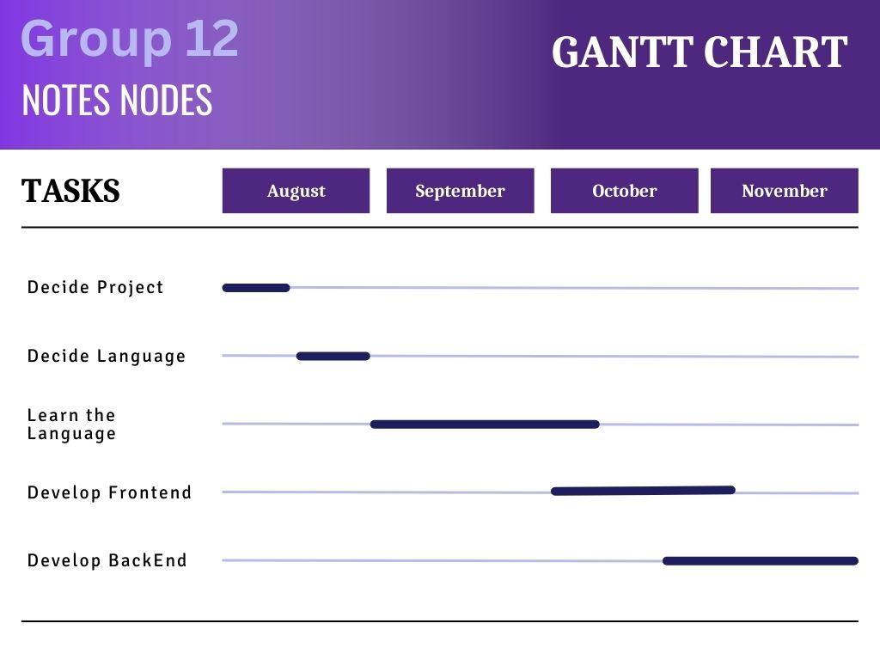

**Tools required:**

* **Hardware Requirements:**

Dual Core Processor

1 GB RAM

500MB Storage

Built-in Camera

* **Software Requirements:**

Android 8 or higher

Pdf Viewer

Word Viewer

Internet Connection

**Signature of Project Supervisor: _____________________**